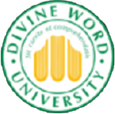

|  |  |
| --- | --- |
| image2.jpeg |  |
| image1.jpeg |  |

**MASTER OF RESEARCH METHODOLOGY** **(MRM)**

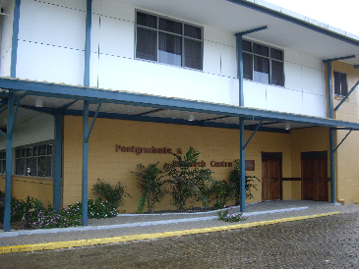

DWU Postgraduate Research Centre

The Master of Research Methodology (MRM) program specializes in research paradigms, methodologies and methods that are relevant across all disciplines. The student’s choice of a research problem to investigate influences the faculty from which supervisors will be drawn.

The MRM program is offered in blended learning mode. Students take two units a semester and complete the program in two and a half or three years. Students are required to participate in a two-week residential component that will usually be scheduled in June (during the semester break at the University) and in November at the end of the second semester at the University. Students are expected to have their own personal laptop and reliable internet connectivity.

**MRM indicative unit sequence**

RM610 Theory & Methods for Applied Research

RM611 Research Methods to advance the Sustainable Development Goals

RM606 Ethics in Research

RM612 Methods in Research Design

RM613 Resources for Applied Research

RM603 Crafting the Literature Review

RM607 Developing the Research Proposal

RM605 Interpreting & Analyzing Data

RM608 Dissertation

Each unit has a 15 credit point value except the dissertation which has 30 credit point. students are required to gain 150 credit points to be eligible to graduate with the award.

**Purpose**

The MRM program aims to produce graduate capable of undertaking research using appropriate research methods. Skills gained are ideal for students wishing to pursue doctoral studies at a later date.

**Facilities**

Divine Word University offers excellent, modern, residential, teaching and ICT facilities in a beautiful, friendly and peaceful environment.

**Admission requirements**

Applicants must normally hold a bachelor’s degree with an average grade of Credit or higher. Applicants may also be asked to demonstrate English writing skills before being accepted.

**Costs**

K100 non-refundable application fee

K5000 per semester (2 units) for tuition, internet access when on campus and supervisory services

Travel, accommodation and meals are additional. Current fee for on-campus accommodation and meals is K1470 per fortnight (K105 per day).

**Account details for fee payments**

Bank BSP Madang

Branch No. 960

Account No. 1000 433 578

Account name TDEC/DWU

**For application forms or information, contact:**

The Enrolment Officer

Flexible Learning Centre

Divine Word University

PO Box 483

Madang, 511, Papua New Guinea

Ph. (675) 424 1870

Fax (675) 422 1312

Email: [ffl@dwu.ac.pg](mailto:ffl@dwu.ac.pg)

Information will be passed on to the Research and Higher Degrees Centre.

**Check our website**: [www.dwu.ac.pg](http://www.dwu.ac.pg)