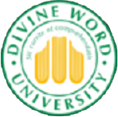

|  |  |
| --- | --- |
| image2.jpeg |  |
| image1.jpeg |  |

**DOCTOR OF PHILOSOPHY (PhD)**

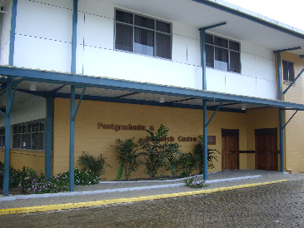

DWU Postgraduate Research Centre

The Doctor of Philosophy (PhD) program is completed by a research thesis of about 80,000 words on an approved topic under the guidance of a supervisory team. The candidate demonstrates the capacity to carry out independent research.

The PhD program is offered in both full-time and part-time study modes. Students are required to maintain regular communication with their supervisory team, to have their own personal laptop and reliable internet connectivity.

The PhD program culminates with external examination of the thesis, to be passed for the candidate to be eligible for the award. The normal period of candidature is three years full-time or six years part-time.

**Purpose**

The PhD program aims to produce scholars and scientists able to conduct research autonomously and to be able to contribute to the National Research Agenda. The PhD award by thesis alone is recommended for those in (or aiming to enter) an academic position or a professional research post.

**Facilities**

Divine Word University offers excellent, modern, residential, teaching and ICT facilities in a beautiful, friendly and peaceful environment. PhD students have the dedicated Moramoro Laboratory in the DWU Postgraduate and Research Centre in which to work.

**Admission requirements**

Applicants will normally have completed a Master’s degree, with an average grade of Distinction or higher. English writing skills are a concern and applicants may be asked to demonstrate these before being accepted.

**Costs**

K100 non-refundable application fee.

K2500 a semester for part-time students.

Current charges for on-campus accommodation and meals are K105 per day.

**Account details for fee payments**

Bank BSP Madang

Branch No. 960

Account No. 1000 433 578

Account name TDEC/DWU

**For application forms or information, contact:**

The Enrolment Officer

Flexible Learning Centre

Divine Word University

PO Box 483

Madang, 511, Papua New Guinea

Ph. (675) 424 1870

Fax (675) 422 1312

Email: [ffl@dwu.ac.pg](mailto:ffl@dwu.ac.pg)

Information will be passed on to the Research and Higher Degrees Centre.

**Check our website**: [www.dwu.ac.pg](http://www.dwu.ac.pg)