Divine Word University

Application to a Doctoral or PhD Program

Surname First Name Middle Name

Previous surname if changed

Educational qualifications

Year
start &
finish
Award (certificate, diploma, degree)
Specialisation Institution & location
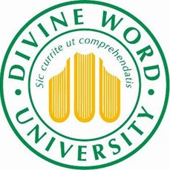

Please attach a photocopy of your Masters Degree award and transcript showing results.

Work experience in recent years, beginning with the most recent first.

Dates Position Location Kind of work

Do you plan to study full time or part time?
Full time will take a maximum of 4 years and part-time would take 6 years. There are clear advantages, even for part time students, to devote some period of full time study on campus at Madang during either data analysis and/or thesis chapter writing. If you intend to study part- time please note that there are attendance requirements and email expectations for regular contact with your supervisor.

Plans for study
You are asked to write a preliminary outline of your proposed research topic. It should be between 1500 - 2000 words in length and should cover
• The issue/problem you wish to explore and question to be answered by your research
• Why it is important and/or original
• How, in broad terms, you propose to approach it. (Attach an additional sheet if necessary)
Describe any previous work you have done in this area, with reference to relevant papers you have written or literature you have read.

Mention any equipment or travel requirements associated with your proposed work

Briefly describe how you will be able to work with your supervisor.
Mailing address

Email address

Telephone home Telephone work

Fax Email

Place of Birth Date of Birth Gender

Country of citizenship

Expected place of residence during your study program

Do you have any disabilities that might possibly impact upon your study? If yes, please specify.

Declaration by Applicant
I declare that the above information is true and correct to the best of my knowledge and belief.

Signature: Date

Please send to: The Executive Officer, pgrc@dwu.ac.pg ; Postgraduate and Research Centre, Divine Word University, P O Box 483, Madang. Papua New Guinea. Please remember to attach a copy of your Masters Degree and a copy of your transcript.

